**Unit 6**　**In a Nature Park**

**Part A** (**1**)

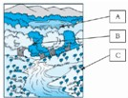词汇 积累练

一、补全单词并对号入座。(24分)

(　　)1.fl__ __er

(　　)2.f__r__st

(　　)3.l__k__

二、选出相应的图片。(16分)

(　　)1.mountain　　　A.QQ截图20121206094635 (　　)2.clouds B. 

(　　)3.flowers C.QQ截图20121206094656 (　　)4.grass D. QQ截图20121206094704

语句 应用练

三、单项选择。(15分)

(　　)1.Look！There are some white clouds________the sky.

A．on　　　　 B．in　　　　 C．over

(　　)2.There________a mountain near our school.It's green.

A．am B．is C．are

(　　)3.There is a forest________the nature park.We often play games in it.

A．over B．at C．in

情景 交际练

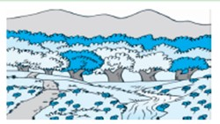四、根据图片及首字母提示，补全对话。(24分)

Amy：There is a nature park i______ our city.

Sarah：Really? What's it l______？

Amy：There is a f______ and a river in the park.There is

a p______ and many f______ near the river.And there are

many m______ in the nature park.

Sarah：How nice!

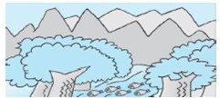表达 交流练

五、描述下面这幅图片。(3～4句话)(21分)

This is a picture of a nature park.What's in it?

There is a

___________________________________________

___________________________________________

___________________________________________

____________________________________________

**答案详解**

一、1.C　o，w　2.B　o，e　3.A　a，e

二、1.C　2.D　3.B　4.A

三、1.B　2.B　3.C

四、in，like，forest，path，flowers，mountains

五、范例：This is a picture of a nature park.What's in it？There is a forest and many mountains in the park.There is a river in the forest.There are many fish in the river.

网资源www.wang26.cn专业学习资料平台